Nexora record profiles and related information
Document 8 of the Nexora learning guides
Source snapshot 13 October 2026 at 17:12 UTC
Understand structured profile fields, taxonomy, audit history and record sections.

Recognise the screen and its scope
Open /relationships/contacts, /relationships/accounts. CRM routes use port 3017; member routes use 3018; public website routes can use 3019. Brackets name a route parameter, not text to paste into a browser. Choose a real record or site id from the application.
This guide covers Contact and Account profiles; General information; Profile definitions and typed fields; Taxonomy and departments; Communication methods permissions and social details; Data audit and connected activity.
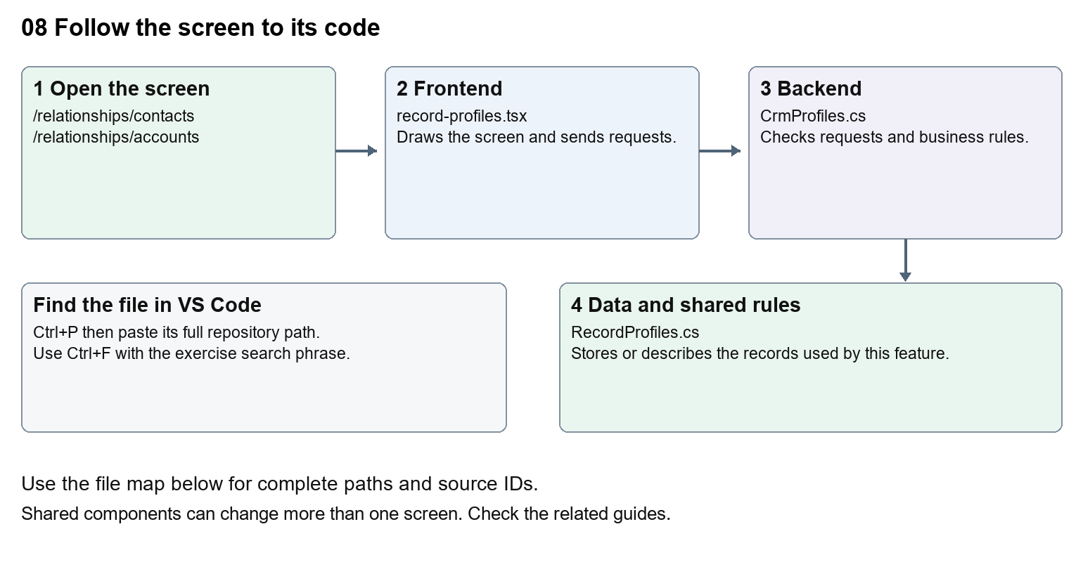
The diagram shows the file roles. The full paths below are what you paste into Ctrl+P.

Find the files in VS Code
Role | File and source ID | What it does
Screen | S0088 record-profiles.tsx | Main UI or route for this topic
Server | S0251 CrmProfiles.cs | Endpoints or server rules
Data | S0256 RecordProfiles.cs | Data shape or persistence structure

Screen S0088
apps/web/src/features/crm/record-profiles.tsx
Server S0251
backend/src/Modules/Nexora.Modules.Crm/CrmProfiles.cs
Data S0256
backend/src/Modules/Nexora.Modules.Crm/Domain/RecordProfiles.cs
The complete HTML manual opens these source IDs inside its Source library. The Word manual shows short labelled extracts so you can learn the flow before reading large files. Each individual Markdown guide includes its complete primary files after the walkthrough.

Follow the request and the records
1. The record detail loads the available profile definitions.
2. A profile component draws fields based on the definition.
3. Saving sends typed values and a version through the CRM API.
4. The server validates field definitions and persists values for that record.
5. Audit and timeline components explain changes and connected module activity.

Read the code with an explanation
A profile definition describes which fields appear and how they are typed. A profile value stores one record's answer. This differs from adding a fixed property to a C# class, which may require a database migration. A department lookup and a free-text job title also have different storage rules. Follow the definition, value and UI component together.
Source reference S0088 apps/web/src/features/crm/record-profiles.tsx
Selected opening lines with their original numbers. The complete file is in the HTML source library.
0001 "use client";
0002 import { RecordSection } from "./record-section";
0003 import { useEffect, useState } from "react";
0004 import { crm } from "./api";
0006 export type ProfileAssignment = { slot: number; definitionId: string; parentNode: string; childNode: string; isArchived: boolean };
0007 type Definition = { id: string; parentNode: string; childNode: string; isArchived: boolean; version: string };

The import lines lead to shared components and helpers. Start at the exported component or route function; follow the request helper to the server rather than assuming the whole feature lives in this file.
Source reference S0251 backend/src/Modules/Nexora.Modules.Crm/CrmProfiles.cs
Extract from source line 12. A fragment from a long line is shown without the rest of that line.
0012 public static partial class CrmModule

On the server, look for MapGet to load records, MapPost to create or perform an action, MapPut or MapPatch to change data, and RequireAuthorization for permissions. Some shared methods register endpoints indirectly. Find SaveChangesAsync to see the database write. A request method alone does not tell you every side effect.
Source reference S0256 backend/src/Modules/Nexora.Modules.Crm/Domain/RecordProfiles.cs
Selected opening lines with their original numbers. The complete file is in the HTML source library.
0001 namespace Nexora.Modules.Crm.Domain;
0003 public sealed class ContactProfile : RecordChild
0004 {
0005 public string? Title { get; set; }
0006 public string? FirstName { get; set; }
0007 public string? MiddleName { get; set; }

Follow model fields to their request names and database mapping. An id points to a particular record. A tenant id limits the organisation. A version or concurrency stamp protects newer edits. Some model files describe contracts rather than tables; check the owning DbContext before assuming storage.

Make or trace your first change
1. Press Ctrl+P and open apps/web/src/features/crm/record-profiles.tsx.
2. Press Ctrl+F and search for export function. In this snapshot it appears at line 11.
3. Read-only exercise: find the exported profile component and its imports. Follow RecordProfiles to its API requests, then find the matching server file. Identify where a displayed profile name comes from data rather than hardcoded JSX.
4. Record the file, request path and server handler you found. This exercise is read-only; no stored records need to change.
Extract from source line 11. A fragment from a long line is shown without the rest of that line.
0011 export function RecordProfiles({ id, version, assignments, e

These exercises have not been applied to the application. Their search phrases are verified against the captured source. Line numbers can move; the phrase and file path are your main navigation aids.

Check a change and diagnose problems
Confirm the original screen still loads, the changed words appear in the intended place, and another screen using the same component still behaves correctly. If an action fails, inspect the browser Network response, the relevant helper and server validation message. Use the common error table at the beginning of the manual. Reload on a version conflict instead of removing the version check.
A syntax error after a text edit usually means a quote, brace or closing tag changed. Compare your diff with the original. An unchanged browser result can mean the wrong port, a saved published configuration overriding a default, or a running API that has not reloaded.

Understand the current limits
The browser may show configured sections, but validation stays on the server. Historical audit rows are evidence of stored changes, not proof that every external system has synchronised.

Continue learning
Related guides 05 Nexora CRM contacts, 06 Nexora CRM accounts and associations, 21 Nexora automation controllers.

